Standard Spelling Dictionary

What is Standard Spelling Dictionary
# Source: AI Source: Provided by: [Data Path: Persons Table -> ID Column: 1, Name_En Column: Motasem Essam] -> From: [Chatgpt (GPT-4-turbo)] on [7/30/2025]
A Standard Spelling Dictionary is the most basic and widely used type of spelling dictionary. It provides an alphabetical list of correctly spelled words, often with minimal extra information. Its primary purpose is to help users verify the correct spelling of a word.

✅ Key Features:
# Source: AI Source: Provided by: [Data Path: Persons Table -> ID Column: 1, Name_En Column: Motasem Essam] -> From: [Chatgpt (GPT-4-turbo)] on [7/30/2025]
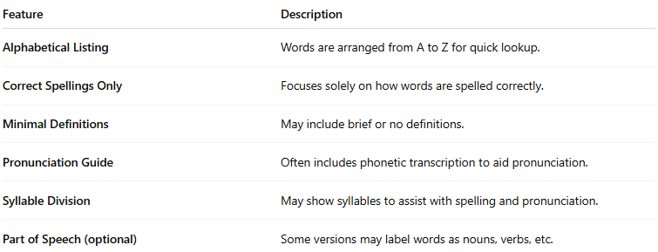
Feature | Description
Alphabetical Listing | Words are arranged from A to Z for quick lookup.
Correct Spellings Only | Focuses solely on how words are spelled correctly.
Minimal Definitions | May include brief or no definitions.
Pronunciation Guide | Often includes phonetic transcription to aid pronunciation.
Syllable Division | May show syllables to assist with spelling and pronunciation.
Part of Speech (optional) | Some versions may label words as nouns, verbs, etc.

👤 Target Audience:
# Source: AI Source: Provided by: [Data Path: Persons Table -> ID Column: 1, Name_En Column: Motasem Essam] -> From: [Chatgpt (GPT-4-turbo)] on [7/30/2025]
- General readers
- Students
- Teachers
- Writers
- Proofreaders

📘 Examples:
# Source: AI Source: Provided by: [Data Path: Persons Table -> ID Column: 1, Name_En Column: Motasem Essam] -> From: [Chatgpt (GPT-4-turbo)] on [7/30/2025]
- Merriam-Webster’s Spelling Dictionary
- Collins English Spelling Dictionary
- American Heritage Dictionary of the English Language (spelling-focused sections)

🟢 Benefits:
# Source: AI Source: Provided by: [Data Path: Persons Table -> ID Column: 1, Name_En Column: Motasem Essam] -> From: [Chatgpt (GPT-4-turbo)] on [7/30/2025]
- Quick spelling reference
- Easy to use
- Good for basic literacy and writing support

🔴 Limitations:
# Source: AI Source: Provided by: [Data Path: Persons Table -> ID Column: 1, Name_En Column: Motasem Essam] -> From: [Chatgpt (GPT-4-turbo)] on [7/30/2025]
- May not include definitions or usage examples
- Does not highlight common misspellings or provide correction strategies

